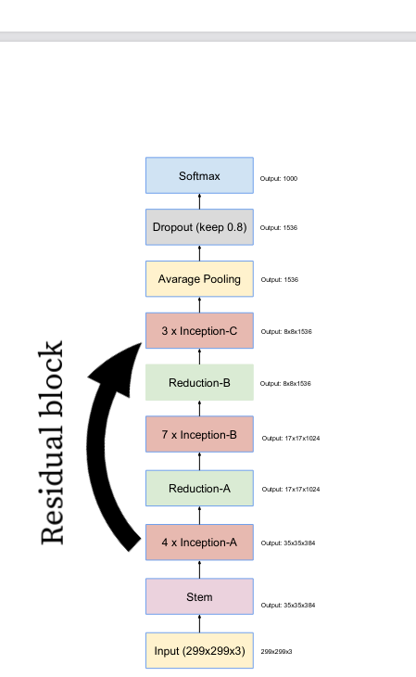

In this network there are only residual blocks inside the inception blocks, so we added the residual block between the inception module because over dataset images contain the diverse features and there are some very small and very large spatial images therefore we used this residual module between the inception module so that we can transfer these very small features to the end of the network without destroying temporal information inside the feature map.

